Methodist Le Bonheur Healthcare Pharmacy Residency Programs
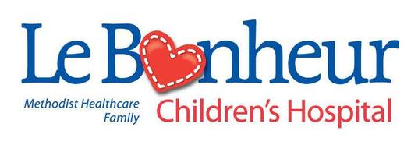
PGY1 Candidate Personal Statement Questions
Candidate Instructions | Please answer each of the following questions. Completed assessment questions should be uploaded to PhORCAS® as a “personal statement.” DO NOT upload a traditional personal statement / letter of intent.

Why do you feel our program is the ideal residency program for you (250 word limit)?

What two characteristics do you possess that you believe make you an ideal residency candidate (250 word limit)?

As a student pharmacist, have you been involved in the following stages of research? (Please answer “Yes” or “No” to each question).
- Generating a research idea?
- Completing an institutional review board application?
- Collecting / abstracting data?
- Analyzing data in statistical software and interpreting the results?
- Writing a research abstract or manuscript?

Le Bonheur Children’s Hospital applicants only:
Please describe why you would like to complete your PGY1 residency at a children’s hospital instead of an adult hospital (250 word limit)?

